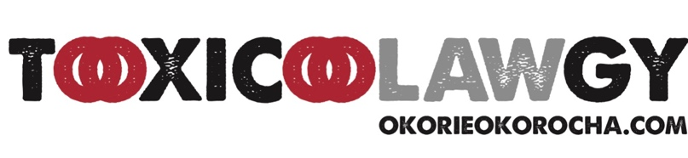

Okorie Okorocha
OO@OOESQ.COM
Cell/Text: (310) 497-0321

Laboratory Litigation Package Template with cheat sheet for attorneys to explain the need for the documents to the Judge.

1. A copy of all of the chain of custody documents including intra-laboratory documents for the sample(s) in question.

Reason discovery is needed: to demonstrate that a strict chain of custody was maintained for the sample in question and ensure that no tampering or mishandling occurred. The laboratory has to have this information readily available or the test should not be used as evidence.

2. A copy of the analytical method used to perform all analytical tests on any specimen including the written method, the method software used and the method software settings and any method validation studies performed for the test results in question

Reason discovery is needed: to demonstrate that proper methods were utilized to analyze the sample in question and to identify the claimed analyte. The laboratory should have this document readily available and it should be widely distributed to all laboratory personnel. It would be impossible to run a laboratory without this document.

3. A copy of the qualifications, curriculum vitae, certifications, licenses, and permits of any individual performing analysis of the specimen in question

A copy of the qualifications, certifications, licenses, and permits of any individual performing analysis of the specimen in question.

4. A clear high resolution copy of all chromatograms, mass spectra and calibration tables of calibrators, controls and samples.

Reason discovery is needed: to ensure that data was processed correctly and that proper quality control was performed to identify any analytes in the sample in question. This information can be retrieved in very little time from the laboratory computer.

5. A clear high-resolution copy of all chromatograms, mass spectra and calibration tables of any reference standards used in the method validation or sample analysis.

Reason discovery is needed: to ensure that proper reference standards were utilized to correctly identify the analyte in the sample in question. This information can be retrieved in very little time from the laboratory computer.

6. Sample worklist and chromatograms and results for all samples analyzed with the subject (defendant) samples.

Reason discovery is needed: to verify that any and all conclusions drawn about the sample in question are supported by the data collected. This information is easily retrieved from the laboratory computer.

7. A copy of all correspondence (including emails and handwritten notes), regarding the testing of any and all samples in this case.

Reason discovery is needed: To ensure that all testing and information transfer occurred utilizing proper lab protocol. This information should be in the laboratory data from the run.

8. Any statement of uncertainty regarding the quantitative results and all data and calculations used in the determination of any statement of uncertainty.

Reason discovery is needed: to ensure that all testing conducted and results reported on the sample in question was performed using scientifically- acceptable standards and protocols. This information is readily available in any laboratory.

9. The current good laboratory standard, starting operating procedures or any other procedures in effect.

Reason discovery is needed: to ensure that all testing conducted and results reported on the sample in question was performed using scientifically-acceptable standards and protocols. This information is readily available in any laboratory.

10. All documents provided by the manufacturer to the laboratory and/or laboratory staff in any fashion, including, but NOT limited to manufacturer manuals, operating manuals, and any other manufacturer literature whatsoever.

This information is needed to determine if the manufacturer, guidelines and protocols, were followed.

